declaring the content of our new internal table using the include structure statement. This just simply copies the structure we declared for itab01 one and includes it in itab02.

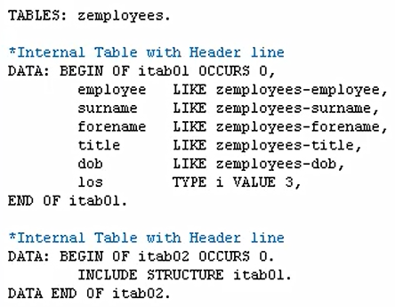

We could also use the structure of a table that we declared in the data dictionary.

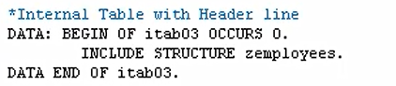

And instead of the internal table, bring in the structure of zemployees. Using this method to declare fields of an internal table can save additional coding and can be enhanced further by including multiple table structures, all within one single Internal table.

